Parapara Lower Gorge
5 Km south of Collingwood, Golden Bay.

From a Kayaking guide book, a bedrock gorge with lots of small drops and pools. Kayaking flows are 8-15 cumecs, so something around 2-3 cumecs might be sensible for a Canyoning descent.
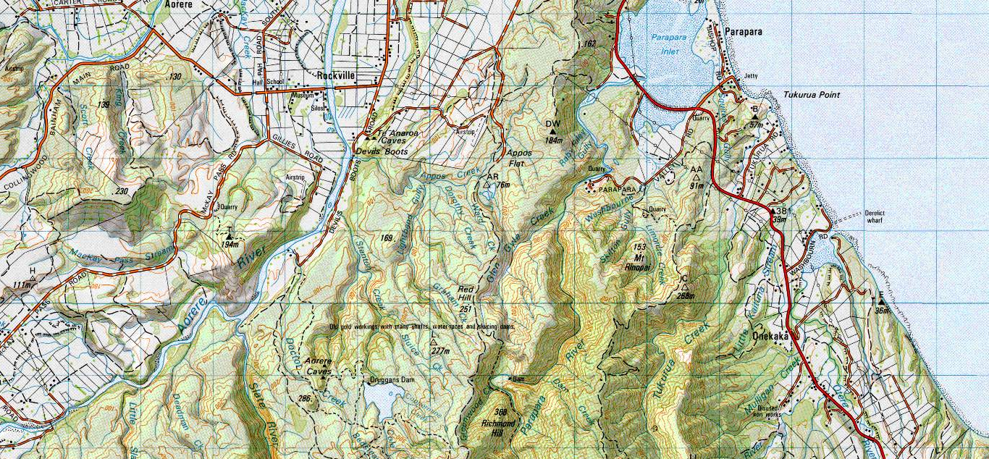
Public Access by walking the 4wd track from the end of ‘Plain Road’ at Appos flat, then left via single track to the creek just north of Richmond Hill.

