Hodgekinson Creek

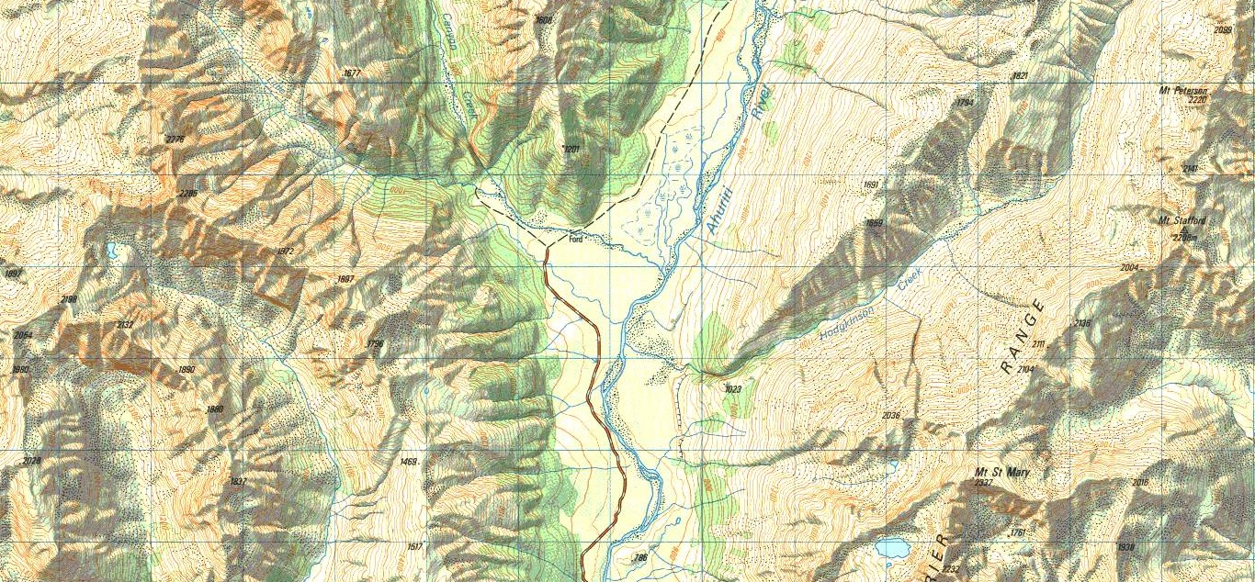
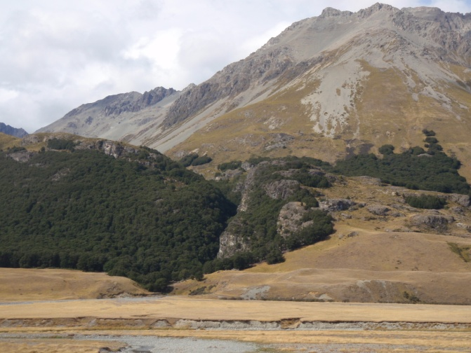
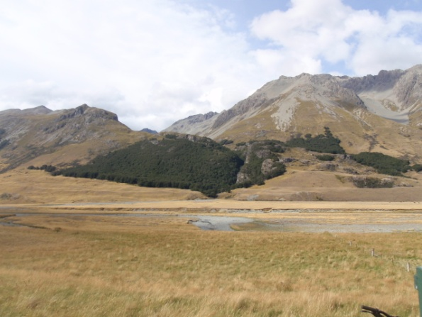
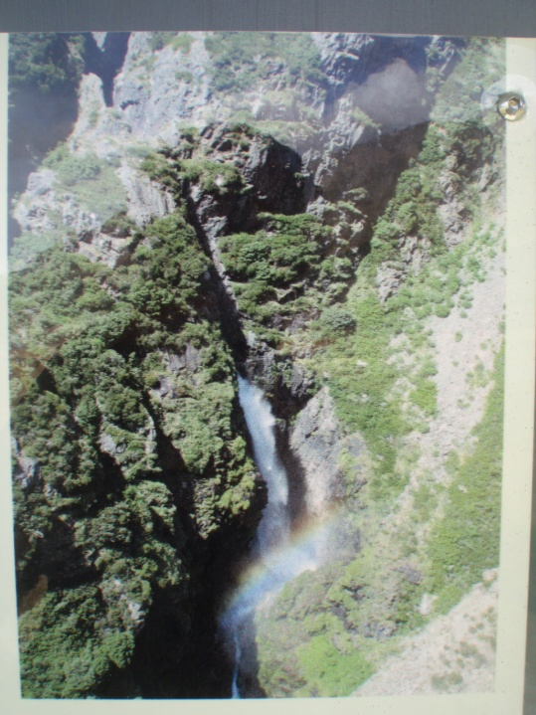
Spotted on an MTB trip. Aerial shot is from the information sign near canyon creek (which isn’t really a canyon). Looks like there could be a short series of canyon drops. Plenty of water, easy access.

