Top Wairoa River,
Red Hills , Richmond

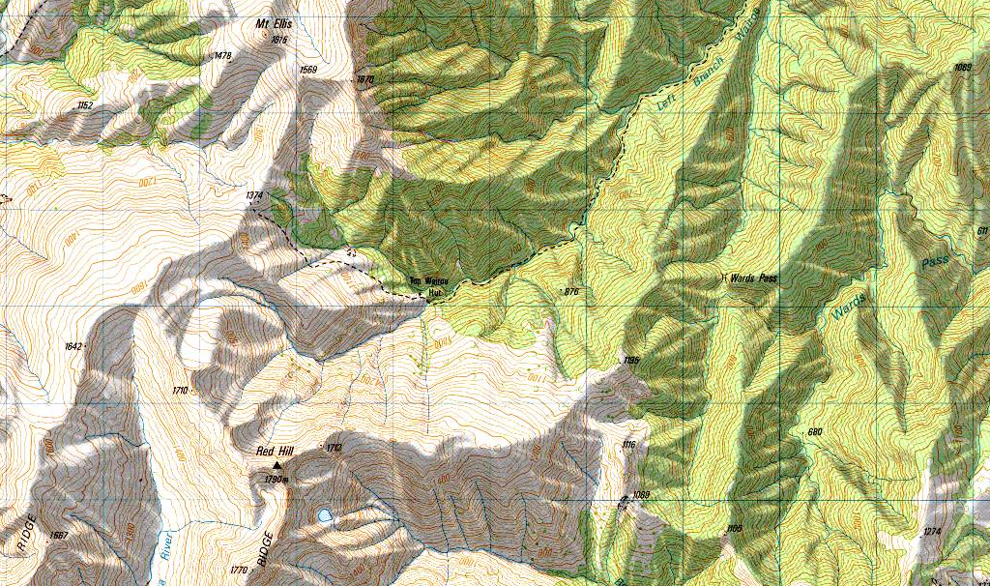
The Top Wairoa Hut sits directly between the two creeks and both gorges start just downstream of the hut. Grid references here. The gorges don't seem to be too long and I bet they both can be done in a day. Pretty spot and a nice hut nearby would make it a nice trip I reckon.
-Nic

