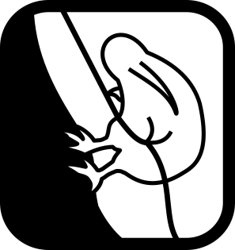

CANYON NAME

**Canyon,Stream,Creek**

**Location**

General Area

**Map**

Topo50 sheet number and name. Illustrated map or Grid references

**Character**

Nature of the Canyon; Steep waterfall stream, slot canyon, Gorge float trip, tricky bush bash, particularly dangerous etc etc

**Approach by Car**

How to get to the Vehicle Park from the nearest major landmark/intersection.

**Approach on Foot**

How to get from the Vehicle Park to the top of the Canyons

**Rock**

Type and solidity

**Water**

How deep/how cold? How much water flow?

**Catchment**

2 Sig Fig km2 (Note if glacially fed)

**Anchors**

Ease of construction. Natural or Artificial. Trees or slung boulders etc.

**Gear**

Rope lengths, and any special technical gear

**Route Description**

Route Description

**Time**

Vehicle park to start of canyon 1hr

Canyon descent 1h30min

Return to Vehicle 20min

**Total 3h**

**Flash Flood Danger**

Subjective opinion on the danger

***v1a3III(grade)***

**Escapes**

Options for leaving the Canyon

**Notes**

First descent:

Access issues

Commercial Canyon?

Remarks?

Etc…